Informal Diction

🗣️ What is Informal Diction
# Source: AI Source: Provided by: [Data Path: Persons Table -> ID Column: 1, Name_En Column: Motasem Essam] -> From: [Chatgpt (GPT-4-turbo)] on [7/30/2025]
Informal diction is relaxed, conversational language used in everyday speech and casual writing. It reflects natural speaking patterns, and often includes contractions, slang, idioms, and personal tone.

✅ Key Features:
# Source: AI Source: Provided by: [Data Path: Persons Table -> ID Column: 1, Name_En Column: Motasem Essam] -> From: [Chatgpt (GPT-4-turbo)] on [7/30/2025]
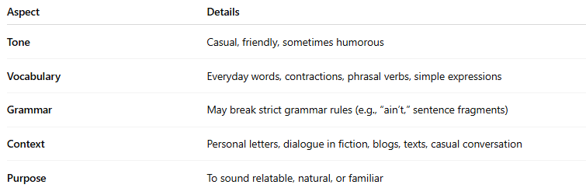
Aspect | Details
Tone | Casual, friendly, sometimes humorous
Vocabulary | Everyday words, contractions, phrasal verbs, simple expressions
Grammar | May break strict grammar rules (e.g., “ain’t,” sentence fragments)
Context | Personal letters, dialogue in fiction, blogs, texts, casual conversation
Purpose | To sound relatable, natural, or familiar

🧠 Examples:
# Source: AI Source: Provided by: [Data Path: Persons Table -> ID Column: 1, Name_En Column: Motasem Essam] -> From: [Chatgpt (GPT-4-turbo)] on [7/30/2025]
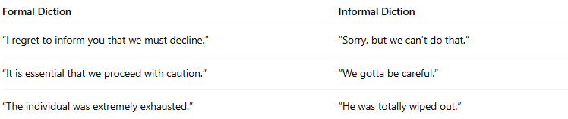
Formal Diction | Informal Diction
“I regret to inform you that we must decline.” | “Sorry, but we can’t do that.”
“It is essential that we proceed with caution.” | “We gotta be careful.”
“The individual was extremely exhausted.” | “He was totally wiped out.”

🔍 Typical Elements in Informal Diction:
# Source: AI Source: Provided by: [Data Path: Persons Table -> ID Column: 1, Name_En Column: Motasem Essam] -> From: [Chatgpt (GPT-4-turbo)] on [7/30/2025]
- Contractions: can’t, won’t, it’s, they’re
- Idioms: hit the books, let the cat out of the bag
- Colloquialisms: guy, cool, chill out
- Sentence fragments: “No idea.” or “Totally forgot.”

📌 Who Uses It & When?
# Source: AI Source: Provided by: [Data Path: Persons Table -> ID Column: 1, Name_En Column: Motasem Essam] -> From: [Chatgpt (GPT-4-turbo)] on [7/30/2025]
- Friends texting each other
- Bloggers speaking directly to readers
- Characters in stories and movies
- Teachers explaining in a relatable way

📊 Comparison Snapshot:
# Source: AI Source: Provided by: [Data Path: Persons Table -> ID Column: 1, Name_En Column: Motasem Essam] -> From: [Chatgpt (GPT-4-turbo)] on [7/30/2025]
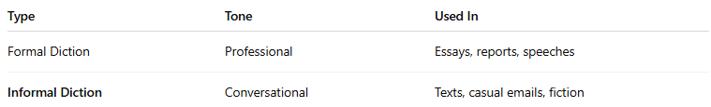
Type | Tone | Used In
Formal Diction | Professional | Essays, reports, speeches
Informal Diction | Conversational | Texts, casual emails, fiction

